Term Project
LSTM vs Transformer Encoder on AG News Classification
A comparison of both methods, their strengths and weaknesses
Team:
Malik Muhammad Abdullah Hassan - 02621070
Syed Muhammad Shabih Ahmad – 02623026
Zain Shabbir – 02623024
6-20-2026

Table of Contents
Table of Figures 1
Table of Tables 1
Introduction 2
Dataset 2
Models 2
Experiments 3
Results 3
Ablation Study 6
Failure Analysis 6
Conclusion 7
AI Usage Appendix 7
Tools Used 7
What AI Was Used For 7
Incorrect, Incomplete, Or Misleading AI Outputs 7
Team Modifications And Decisions 8
Effect Of AI Use 8

Table of Figures
Figure 1: Training and Validation Loss for both Models 4
Figure 2: Confusion Matrix for LSTM 5
Figure 3: Confusion Matrix for Transformer Encoder 5

Table of Tables
Table 1: Results for the Validation and Test Sets for Both Models 3
Table 2: Results of the Data Fraction Ablation Study 6
Table 3: Results of the Length Ablation Study 6
Table 4: Failure Analysis of selected errors 7

Introduction
Text classification is one of the standard ways to evaluate whether a neural network can turn raw language into useful categories. In this report, we compare an LSTM classifier and a Transformer Encoder classifier on the same AG News task. The research question is: when dataset source, preprocessing, training budget, and metrics are controlled, does the recurrent LSTM or the self-attention Transformer Encoder give better classification performance?
The comparison is interesting because the two models represent different assumptions about sequence data. The LSTM reads the text recurrently and carries information through a hidden state. The Transformer Encoder uses self-attention, allowing every token to interact with other tokens directly.

Dataset
AG News is a four-class news classification dataset. Each input is a short news text, and the model predicts one of four categories: `World`, `Sports`, `Business`, or `Sci/Tech`. The project uses Hugging Face `fancyzhx/ag_news` as the only dataset source. The official training split was divided into 108,000 training examples and 12,000 validation examples using `train_test_split(test_size=0.1, seed=42)`. The official test split contains 7,600 examples and was reserved for final evaluation only.
Labels were verified as integer class indices `0, 1, 2, 3`, matching the requirement for `torch.nn.CrossEntropyLoss`. For preprocessing, the text was tokenized with a reproducible regular-expression tokenizer. The vocabulary was built only from the training split to avoid vocabulary leakage. The vocabulary size was capped at 20,000 tokens, with reserved indices for padding and unknown tokens. Tokens outside this train-built vocabulary map to `<unk>`, and the 20,000-token cap was kept fixed for both architectures and all main ablations. The main comparison used a maximum sequence length of 128 tokens. Both models received the same padded and truncated token IDs, and padding masks were used during LSTM pooling and Transformer attention.

Models
The first model is a bidirectional LSTM classifier. It uses an embedding layer, a one-layer bidirectional LSTM, masked mean pooling, dropout, and a final linear classifier. The second model is a Transformer Encoder classifier. It uses an embedding layer, learned positional embeddings, two Transformer Encoder layers, four attention heads, feedforward dimension 512, masked mean pooling, dropout, and a final linear classifier. Both models were trained from scratch, without pretrained embeddings or pretrained language models.
The parameter counts were set to be reasonably comparable. The Transformer Encoder has about 5.2% more trainable parameters than the LSTM, so we treat its small final metric advantage cautiously. Most parameters in both models come from the shared embedding table: `20,000 × 128 = 2,560,000` embedding parameters, or about 90.6% of the LSTM and 86.1% of the Transformer Encoder. The non-embedding encoder and classifier components differ by about 148,224 parameters, so the total-size mismatch is modest but still worth acknowledging when interpreting small metric gaps.

Experiments
The main comparison trained both models for 6 epochs using Adam, learning rate $1×{10}^{-3}$, batch size 64, dropout 0.2, seed 42, and CPU execution. The evaluation metrics were accuracy and macro F1-score. Macro F1 was included because AG News has multiple classes and the assignment requires class-sensitive evaluation, even though the dataset is nearly balanced.
Two ablation studies were planned.
The first ablation changed one major factor: the fraction of training data. The tested fractions were 25%, 50%, and 100% of the training split. The hypothesis was that the LSTM would be more stable with less data, while the Transformer Encoder would benefit more from the full dataset because self-attention has greater capacity. The 100% ablation run is not numerically identical to the main-comparison run because the ablation helper shuffles the selected training indices even when the selected fraction is 100%; this changes the minibatch order while keeping the same examples, seed, and hyperparameters.
The second ablation compared maximum sequence lengths of 128 and 256 tokens. This tested whether longer context improved validation performance enough to justify the additional training cost.

Results
Both models reached similar final performance. On the official test split, the LSTM achieved 0.9120 accuracy and 0.9118 macro F1. The Transformer Encoder achieved 0.9125 accuracy and 0.9126 macro F1. The Transformer Encoder therefore performed slightly better on the final test metrics, but the difference is small and should not be overinterpreted as a decisive architectural win.
The epoch-1 validation results show a convergence-speed difference: the LSTM reached 0.8957 validation accuracy after one epoch, while the Transformer Encoder reached 0.8835. This suggests that the LSTM reached a usable validation accuracy faster in the first stage of training, even though the Transformer Encoder slightly surpassed it by the final test evaluation.
Model | Split | Loss | Accuracy | Macro F1
LSTM | Validation | 0.340210 | 0.911333 | 0.910771
Transformer Encoder | Validation | 0.310273 | 0.911833 | 0.911486
LSTM | Test | 0.345859 | 0.911974 | 0.911793
Transformer Encoder | Test | 0.306583 | 0.912500 | 0.912640
Table 1: Results for the Validation and Test Sets for Both Models

The loss curves show that both models continued to reduce training loss while validation loss stopped improving and then increased by the final epoch. This indicates overfitting by epoch 6. The LSTM had a sharper training-validation loss gap by the final epoch, while the Transformer Encoder retained slightly lower validation and test loss.
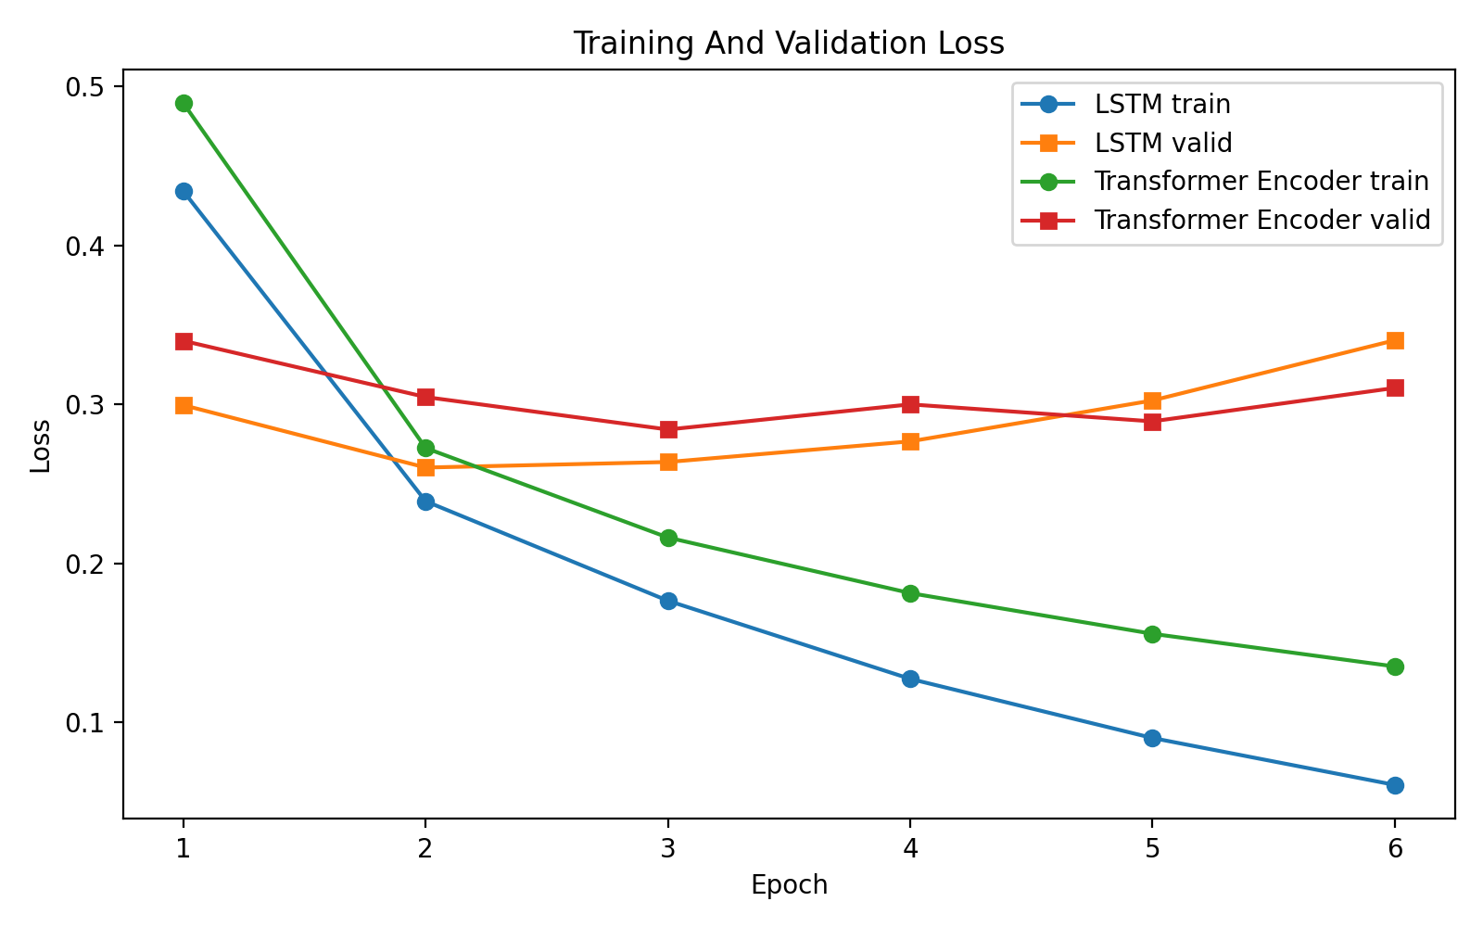
Figure 1: Training and Validation Loss for both Models

The confusion matrices show that Sports was the easiest class for both models. The largest recurring confusion was between Business and Sci/Tech. For the LSTM, 177 Business items were predicted as Sci/Tech and 121 Sci/Tech items were predicted as Business. For the Transformer Encoder, 200 Business items were predicted as Sci/Tech and 93 Sci/Tech items were predicted as Business. Together, these Business/Sci-Tech cross-confusions account for 298 of the LSTM's 669 test errors, or 44.5%, and 293 of the Transformer's 665 test errors, or 44.1%. This directional asymmetry suggests that the Transformer Encoder more aggressively predicts Sci/Tech for business stories with technology-company surface terms, while the LSTM more often maps Sci/Tech stories back toward Business.

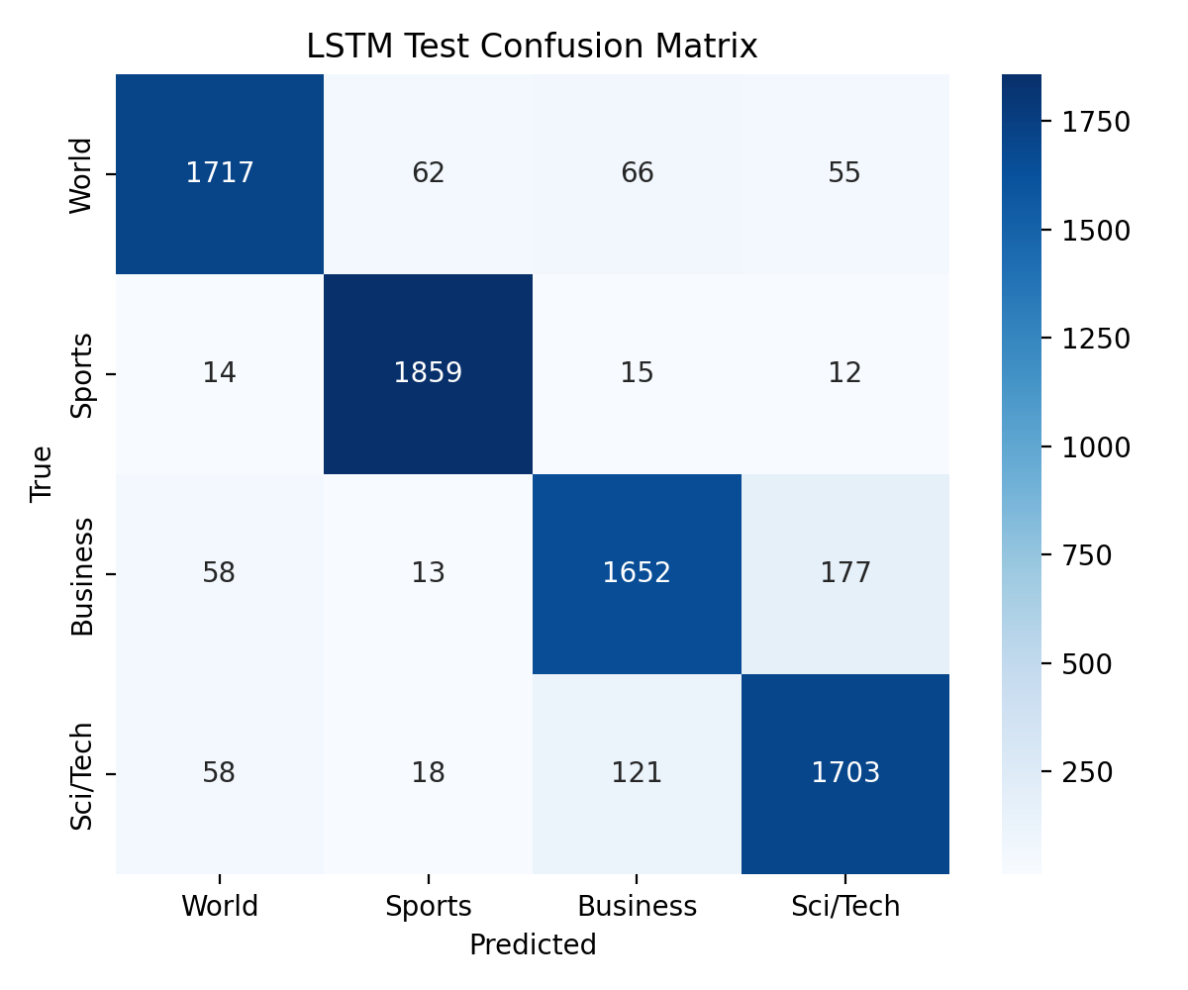
Figure 2: Confusion Matrix for LSTM

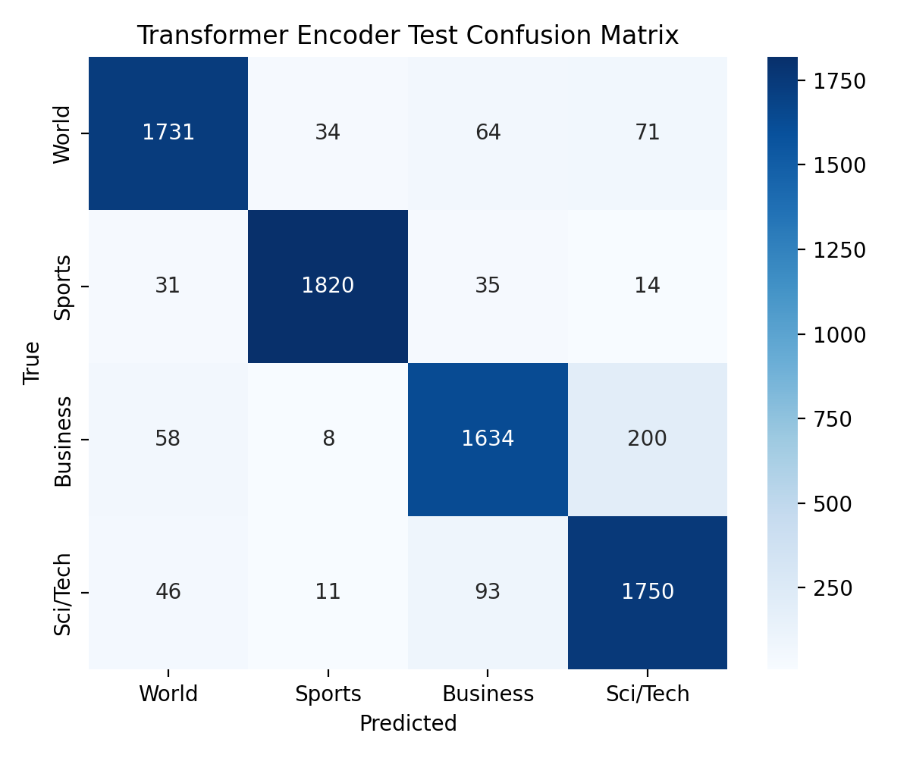
Figure 3: Confusion Matrix for Transformer Encoder

Ablation Study
Hypothesis: LSTM is more stable with limited data, while Transformer Encoder benefits more from full data. The changed variable was training-set fraction; all other major settings were controlled.
Model | Train fraction | Accuracy | Macro F1
LSTM | 25% | 0.8719 | 0.8713
Transformer Encoder | 25% | 0.8699 | 0.8696
LSTM | 50% | 0.8944 | 0.8940
Transformer Encoder | 50% | 0.8901 | 0.8895
LSTM | 100% | 0.9089 | 0.9082
Transformer Encoder | 100% | 0.9146 | 0.9142
Table 2: Results of the Data Fraction Ablation Study
The 100% ablation rows use a shuffled training-index order and therefore are not numerically identical to the main-comparison rows, even though they use the same examples, seed, and hyperparameters.
The ablation supports the hypothesis: LSTM led at 25% and 50%, while Transformer Encoder led at 100%. The LSTM gained +3.70 percentage points from 25% to 100%, while the Transformer Encoder gained +4.47 percentage points.
The second sequence-length extension showed that 256-token inputs reduced validation performance for both models.
Model | Max length | Loss | Accuracy | Macro F1
LSTM | 128 | 0.3402 | 0.9113 | 0.9108
Transformer Encoder | 128 | 0.3103 | 0.9118 | 0.9115
LSTM | 256 | 0.3535 | 0.9065 | 0.9058
Transformer Encoder | 256 | 0.3304 | 0.9062 | 0.9059
Table 3: Results of the Length Ablation Study

Failure Analysis
The selected examples cover both-wrong, LSTM-only wrong, and Transformer-only wrong cases.
# | Input excerpt | True | LSTM | Transformer | LSTM conf. | Trans. conf. | Likely reason
1 | Live: Olympics day four Richard Faulds and Stephen Parry are going fo... | World | Sports | Sports | 0.94 | 1.00 | Sports terms dominate the short text even though the dataset section is World.
2 | Intel to delay product aimed for high-definition TVs SAN FRANCISCO --... | Business | Sci/Tech | Sci/Tech | 0.99 | 1.00 | A technology company story overlaps Business and Sci/Tech vocabulary.
3 | Prediction Unit Helps Forecast Wildfires (AP) AP - It's barely dawn w... | Sci/Tech | World | Sci/Tech | 0.48 | 0.98 | Weather prediction language mixes science terms with world-event framing.
4 | Some People Not Eligible to Get in on Google IPO Google has billed it... | Sci/Tech | Business | Sci/Tech | 0.82 | 0.83 | Finance and technology cues conflict; the IPO framing points toward Business.
5 | Teenage T. rex's monster growth Tyrannosaurus rex achieved its massiv... | Sci/Tech | Sci/Tech | Business | 0.44 | 0.56 | Very short science item gives limited context; the Transformer overweighs business-like wording.
6 | IBM to hire even more new workers By the end of the year, the computi... | Sci/Tech | Sci/Tech | Business | 0.84 | 0.62 | Company hiring story overlaps labor/business cues and computing-company Sci/Tech label.
Table 4: Failure Analysis of selected errors
Most remaining errors are cases involving class overlap or misleading surface cues, not label-format or preprocessing failures. Business/Sci-Tech cross-confusions account for 298 of the LSTM's 669 test errors (44.5%) and 293 of the Transformer's 665 test errors (44.1%).
Conclusion
Both from-scratch models performed well on AG News under the controlled setup, reaching about 91.2% final test accuracy. The Transformer Encoder achieved the best final test metrics, but only by a small margin. The LSTM converged faster in the first epoch and was stronger in lower-data ablation settings, while the Transformer Encoder benefited more from the full training set.
The required dataset-size ablation supports the original data-efficiency hypothesis. The optional sequence-length ablation showed that simply increasing maximum sequence length from 128 to 256 did not improve validation metrics. The most reasonable next experiment would be to tune early stopping or regularization, because both models show overfitting by the final epoch. A further limitation is that the ablations were run with a single seed; repeating the comparison across multiple seeds would make the data-efficiency conclusion more statistically robust.

AI Usage Appendix

Tools Used
Codex was used for project planning, code drafting support, debugging and document review.

What AI Was Used For
AI was used to brainstorm a controlled experiment plan, check the scaffold against dataset-source and test-set rules, and review PyTorch notebook components. For code-level work, AI assistance was used to review the structure. All generated code was inspected and run cell-by-cell, and the masked mean pooling and Transformer padding-mask logic were manually checked against the attention masks.

Incorrect, Incomplete, Or Misleading AI Outputs
During code review, no instances were found of common AI-assisted code errors: applying `softmax` before `CrossEntropyLoss`, normalizing confusion matrices when raw error counts were needed, or using the official test split during model selection or ablation.

Team Modifications And Decisions
The team kept the project constrained to one dataset source, Hugging Face `fancyzhx/ag_news`, and required the official test split to be used only for final evaluation. The team selected dataset-size ablation as the first ablation and kept sequence length as the second option. We also added explicit checks for integer labels, train-only vocabulary construction, padding masks, and reproducible seeds rather than relying on generated code without verification.

Effect Of AI Use
AI reduced the time needed to organize requirements, audit deliverables, draft code scaffolds, and write clear explanations.

